Frappe Installation setup

1. Install git, python, and redis
   * sudo apt install git python-dev python-pip redis-server
   * 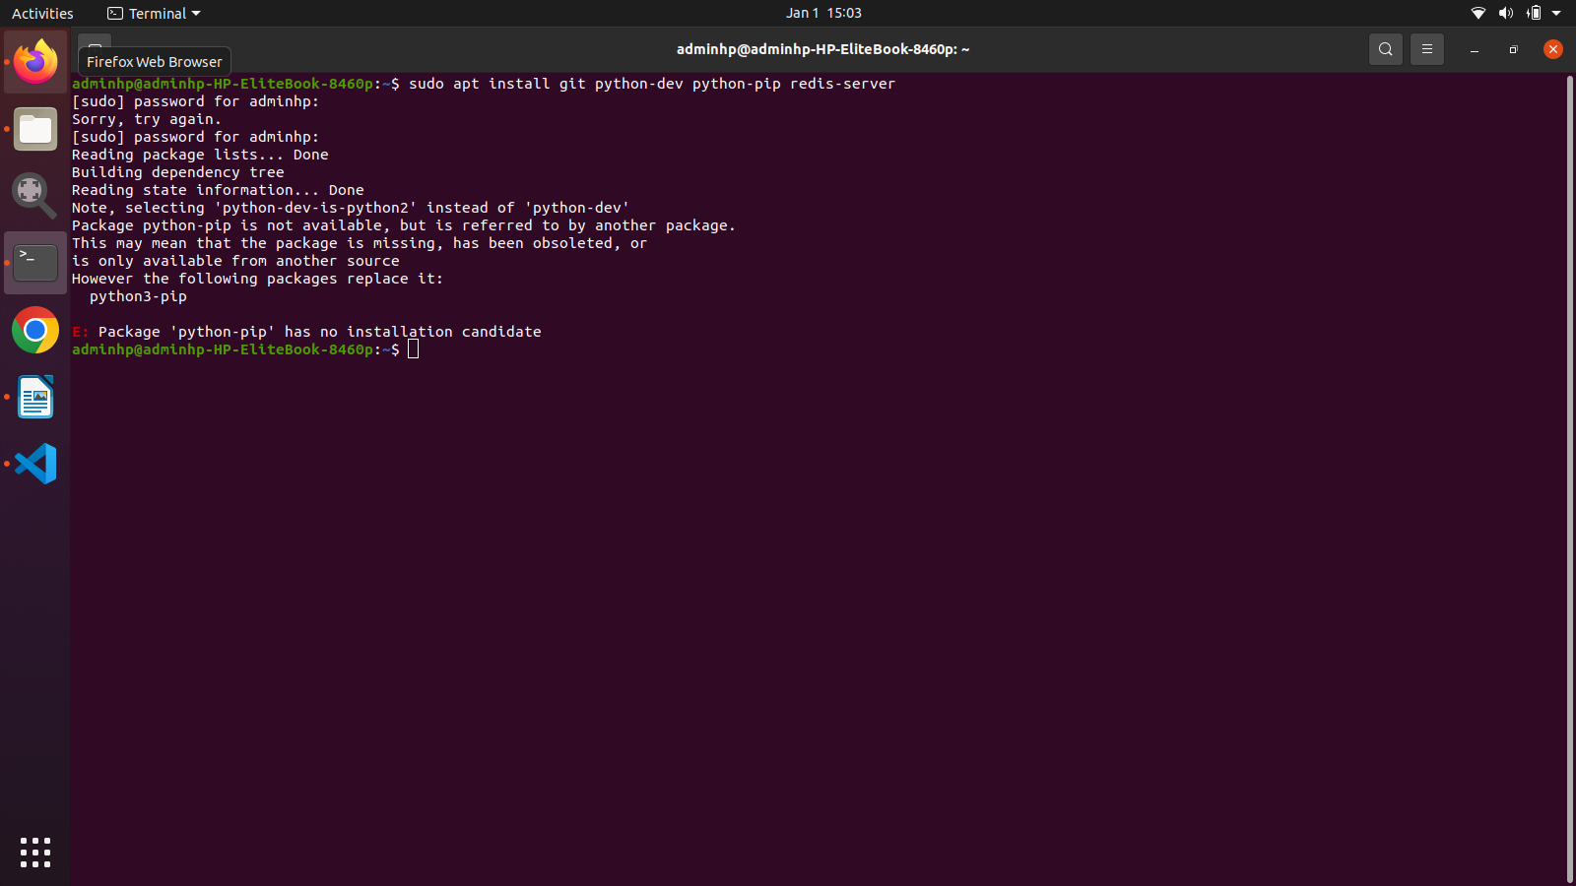You might get this error for python-dev as it is depriciated but any python might work for it
2. Install MariaDB
   * sudo apt install software-properties-common
   * 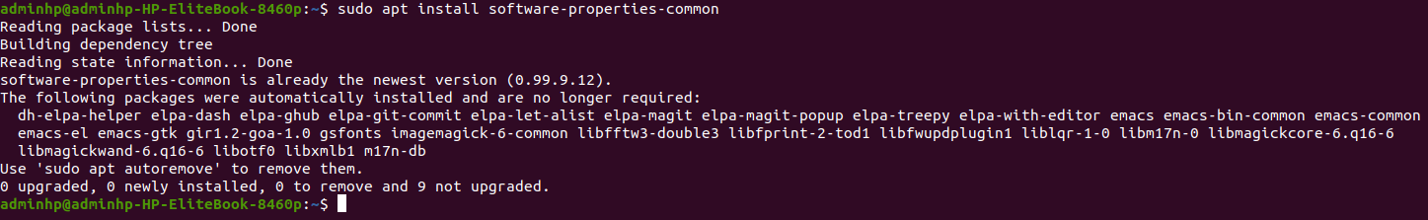 If you are on Ubuntu version older than 20.04, run this before installing MariaDB:
   * sudo apt-key adv --recv-keys --keyserver hkp://keyserver.ubuntu.com:80 0xF1656F24C74CD1D8
   * sudo add-apt-repository 'deb [arch=amd64,i386,ppc64el] http://ftp.ubuntu-tw.org/mirror/mariadb/repo/10.3/ubuntu xenial main'
   * If you are on version Ubuntu 20.04, then MariaDB is available in default repo and you can directly run the below commands to install it:
3. install mariadb
   * sudo apt update
   * sudo apt-get install mariadb-serve
   * 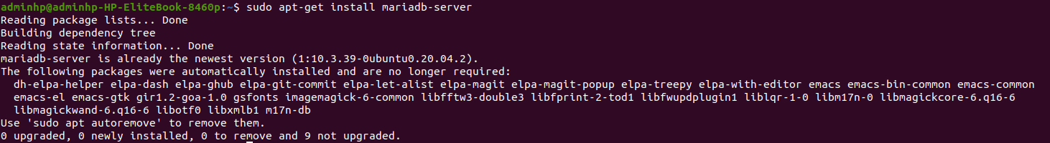During installation, you’ll be asked to set the MySQL root password. If not, you’ll need to initialize the MySQL server manually using this command:
   * mysql_secure_installation
   * if you get error like this:
   * 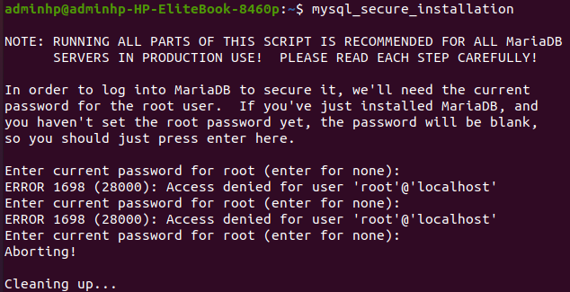use sudo mysql_secure_installation
4. Edit Maria files
   * type nano /etc/mysql/my.cnf or edit in filexplorer
   * and change this:

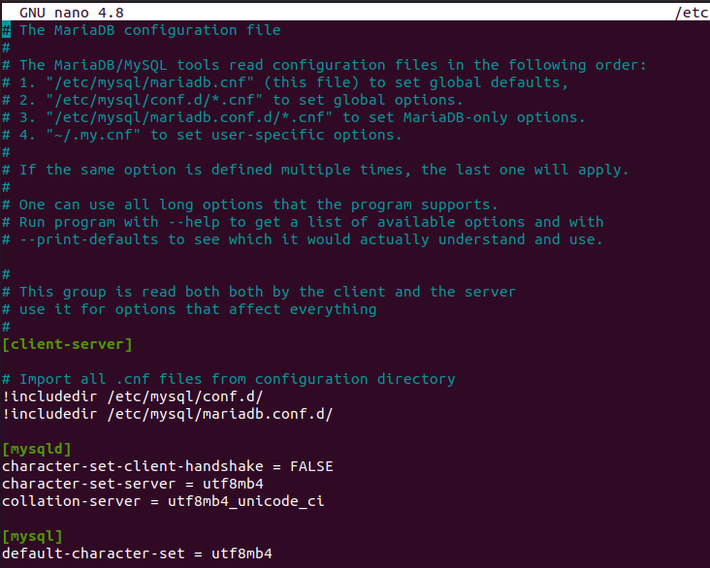

* + now restrart server using:

1. Install Node using npm:
   * 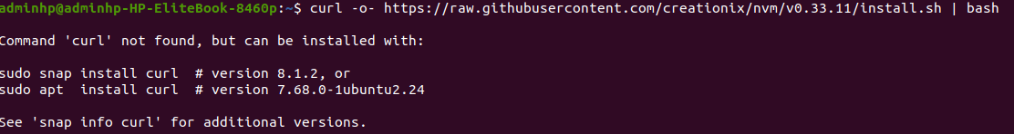don’t worry if you get this error and install curl as suggested
   * then use this command
2. 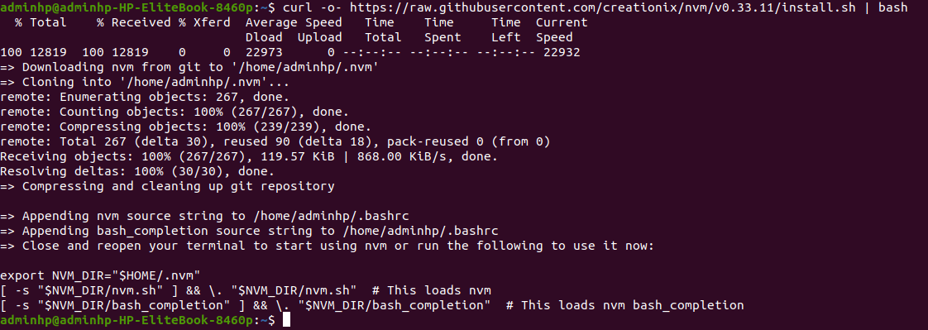install node
   * for installing it first install nvm using :\
   * curl -o- https://raw.githubusercontent.com/nvm-sh/nvm/v0.39.1/install.sh | bash